

**AI-Powered Accident Prevention and Driver Monitoring**

Analysis, Design and Implementation Report

|  |  |
| --- | --- |
| **Student:** | Trinesh Katarapu |
| **Student ID and email:** | W9589499  W9589499@live.tees.ac.uk |
| **Course:** | BSc Computer Science (Hons) |
| **Supervisor:** | Ghareeb Shatha |
| **Second Reader**: | Elkazza Sumeia |

Date: 14.03.25

Supervisor: Ghareeb Shatha

Abstract

To improve road safety through real-time danger detection and driver behaviour analysis, the **AI-Powered Accident Prevention and Driver Monitoring System** combines deep learning-based driver monitoring with **YOLOv8 object detection**. To provide proactive accident prevention, the system uses computer vision and real-time sensor data to detect irregularities in drivers, cars, and pedestrians. Training on **2,704 training photos** and **300 validation images**, the YOLOv8 model obtains a **mAP50 of 0.405** and shows consistent improvement over **25 training epochs**, with classification loss falling from **2.509 to 0.7585** and box loss falling from **1.498 to 1.051**. These upgrades demonstrate the model's ability to accurately identify a variety of vehicle kinds and road users.

A VGG19-based deep learning model analyses a dataset of **8,358 validation photos** and **33,435 training images** for driver sleepiness detection. To enhance generalization and avoid overfitting, the model incorporates dropout layers, batch normalization, and L2 regularization. Over eight epochs, the CNN model stabilizes at **78.68%** **validation accuracy** after reaching **97.89%** **training accuracy.** A Flask-based web application is used to implement the system, which reduces the risks associated with sleepy or distracted driving by offering real-time monitoring and immediate alarms. Future developments will concentrate on increasing model accuracy, incorporating more sensor input, and maximizing inference speed for smooth implementation in driver-assistive and autonomous car systems. This study offers a scalable AI-driven approach that combines cutting-edge deep learning models with real-time monitoring technologies to greatly increase road safety.

Acknowledgements

A sincere thanks to everyone who participated in development of this AI-Powered Driver Monitoring and Accident Prevention System. I'd like to convey my sincere thanks to my advisors & mentors for their continuous encouragement and valuable support during this project. Their knowledge in artificial intelligence, computer vision and traffic safety systems a strongly influenced my work.

I am also thankful to the organizations and institutions that gave me instruction manuals, necessary equipment, and computer resources so that I could investigate and apply cutting-edge AI-driven accident prevention strategies.

The open-source community that created OpenCV, TensorFlow, PyTorch, and other machine learning frameworks is finally acknowledged. An intelligent, real-time monitoring system that improves driver safety and accident prevention was developed in large part because to their contributions.

Statement of Originality

I confirm that the AI-Powered Driver Monitoring and Accident Prevention System is entirely my own creation. I carried out the research, coding, and development on my own, making sure that it complies with ethical and academic norms. To ensure honesty and transparency, all information obtained from other sources has been appropriately referenced. In addition to not having been presented elsewhere for academic or professional purposes, this project is neither plagiarized nor replicated. I accept full responsibility for its uniqueness and attest that it accurately represents my diligence, hard work, and passion to innovation in AI-driven driver monitoring and road safety.

Copyright

This project, the AI-Powered Accident Prevention and Driver Monitoring System, is the intellectual property of its creator. All rights to the research, design, code, and documentation are reserved. It may not be copied, distributed, or modified in any form without prior permission. All external sources have been properly cited, adhering to ethical standards and copyright regulations. This project is intended for research and educational purposes. Anyone wishing to use or modify any part of this work must obtain the author's consent. I retain all legal rights related to the development and implementation of this project.

List of Abbreviations

|  |  |
| --- | --- |
| Abbreviation | Full Form |
| AI | Artificial Intelligence |
| CNN | Convolutional Neural Network |
| ReLU | Rectified Linear Unit |
| HCI | Human-Computer Interaction |
| Flask | Python Web Framework |
| OpenCV | Open-Source Computer Vision Library |
| ML | Machine Learning |
| GPU | Graphics Processing Unit |
| DL | Deep Learning |
| FOV | Field of View |
| FPS | Frames Per Second |

**Table of Contents**

Abstract ii

Acknowledgements iii

Statement of Originality iv

Copyright v

List of Abbreviations vi

List of Figures & Tables xi

1 Introduction 1

1.1 Overview of the Project 1

1.2 Problem Statement 2

1.3 Research Questions & Objectives 2

1.4 Scope & Limitations 2

1.4.1 Scope of the Project 3

1.4.2 Limitations of the Project 3

2 Research and Literature Review 4

2.1 Introduction 4

2.2 Existing Solutions & Their Limitations 4

2.2.1 Tesla Autopilot 4

2.2.2 Mobileye 4

2.2.3 Comparison with Our Approach 5

2.3 AI in Road Safety and Driver Monitoring 5

2.3.1 Role of Computer Vision & Deep Learning 5

2.3.2 YOLOv8 for Object & Vehicle Detection 5

2.3.3 VGG19 for Drowsiness Detection 6

2.4 Driver Behaviour Analysis Techniques 6

2.4.1 Facial Expression Analysis 7

2.4.2 Eye Movement Detection 7

2.4.3 Head Orientation Tracking 7

2.5 Ethical and Privacy Considerations 7

2.5.1 Facial Expression Analysis 7

2.5.2 Eye Movement Detection 7

2.5.3 Head Orientation Tracking 8

3 Methodology 8

3.1 Introduction 8

3.2 Tools and Technologies Used 9

3.3 Data Collection & Processing 9

3.3.1 Data Collection 9

3.3.2 Driver-Facing Camera Data 9

3.3.3 Vehicle Sensor Data 10

3.4 Data Preprocessing Techniques Used 10

3.5 System Architecture & Design Strategy 11

3.5.1 YOLOv8 Model Processing 11

3.5.2 VGG19-Based Driver Monitoring 11

3.5.3 Flask-Based Web Interface 11

4 System Requirements and Design 13

4.1 Functional Requirements 13

4.1.1 Real-Time Driver Tiredness and Distraction Detection 13

4.1.2 Risk Assessment Based on Vehicle Speed, Braking Patterns, and Lane Positioning 13

4.2 Non-Functional Requirements 13

4.2.1 High Accuracy in Driver Monitoring 13

4.2.2 Low-Latency Processing for Real-Time Alerts 14

4.3 System Architecture 14

4.3.1 Input Module 14

4.3.2 Processing Module 14

4.3.3 Output Module 14

4.4 AI Model Design 15

4.4.1 Object Detection Model 15

4.4.2 Driver Monitoring Model 15

4.5 User Interface (UI) and Dashboard 16

4.5.1 Live Dashboard 16

4.5.2 Real-Time Alert System 16

4.5.3 Performance Monitoring 16

5 Implementation 17

5.1 Introduction 17

5.2 Data Collection and Preprocessing 17

5.2.1 Data Sources 17

5.2.2 Data Preprocessing Steps 18

5.3 AI Model Training 19

5.3.1 YOLOv8 for Object Detection 19

5.4 Model Training Process 19

5.4.1 Dataset Preparation and Annotation 19

5.4.2 Transfer Learning Using YOLOv8 20

5.4.3 Model Evaluation and Accuracy Tuning 20

5.5 VGG19 for Driver Monitoring 20

5.5.1 Feature Extraction from Facial Expressions and Eye Movements 21

5.5.2 Balancing Training and Validation Accuracy 21

5.5.3 Validation Against Diverse Test Datasets 22

5.5.3.1 F1-Confidence Curve Analysis 22

5.5.3.2 Precision-Recall 23

5.5.3.3 Precision-Confidence 23

5.5.3.4 Recall-Confidence 24

5.5.4 Final Model Integration 24

5.6 System Deployment 25

5.6.1 Flask-Based Web Application 25

6 Testing and Evaluation 26

6.1 Testing Approach 26

6.1.1 Unit Testing 26

6.1.2 System Testing 27

6.1.3 Real-World Scenario Validation 27

6.2 Performance Evaluation 27

6.2.1 Object Detection Model (YOLOv8) Performance 27

6.2.2 Driver Monitoring Model (VGG19) Performance 28

6.3 Web Application Performance 29

6.3.1 System Architecture 29

6.3.2 Deployment Environment 29

6.3.2.1 Software Requirements 29

6.3.2.2 Hardware Requirements 29

6.3.2.3 Application Workflow 30

6.3.3 Key Performance Metrics 30

6.3.4 Performance Challenges 35

6.3.5 Analysis of Performance Metrics 36

7 Project Challenges & Ethical Considerations 38

7.1 Technical Challenges 38

7.1.1 Hardware Limitations 38

7.1.2 Variations in Lighting Conditions 38

7.1.3 Camera Placement Issues 38

7.2 Ethical Concerns 38

7.2.1 Data Privacy and Security 38

7.2.2 Driver Consent and Transparency 39

7.2.3 Prevention of AI Impairment 39

8 Recommendations and Future Scope 40

8.1 Suggested Improvements 40

8.2 Integration with IoT and Smart Vehicles 40

8.3 Long-Term Usability and Maintenance 41

9 Conclusion 42

9.1 Summary of Key Findings 42

9.2 Limitations & Areas for Improvement 42

9.3 Final Thoughts & Reflection 43

10 References 44

List of Figures & Tables

**List of Figures**

Figure 1: YOLO Release Timeline (2015–2023) 6

Figure 2: Overview of VGG19 Architecture 6

Figure 3: Overview of YOLOv8 Architecture 8

Figure 4: Data loading and visualization 10

Figure 5: Overview of YOLO Architecture 12

Figure 6: Feature Extraction and Classification in a CNN 15

Figure 7: YOLO V8 System Architecture Diagram 17

Figure 8: Visualizing Image Classification with a Convolutional Neural Network 18

Figure 9: Loading YOLOV8 Model 18

Figure 10: Object Detection with Vehicle Classification 19

Figure 11: Confusion Matrix for Model Evaluation 20

Figure 12: Pictures of Sleepy and Awake Drivers with Face Markings 21

Figure 13: Balancing Training and Validation Accuracy 21

Figure 14: F1-Confidence Curve Analysis 22

Figure 15: Precision-Recall Curve 23

Figure 16: Precision-Confidence Curve 23

Figure 17:Recall-Confidence Curve 24

Figure 18: Model Summary Final Selection 26

Figure 19: AI-Powered Vehicle Detection in Urban Traffic 27

Figure 20: Precision Recall Curve for Performance Evaluation 28

Figure 21: Driver Monitoring Model (VGG19) Performance 28

Figure 22: Flask Web Application Hosting 31

Figure 23: Drowsiness and Object Detection Home Page 31

Figure 24: Object Detection Performance on real Time Video image 1 32

Figure 25: Object Detection Performance on real Time Video image 2 32

Figure 26: Object Detection Performance on real Time Video image 3 33

Figure 27: Real Time Webcam Drowsiness Detection Performance image 1 33

Figure 28: Real Time Webcam Drowsiness Detection Performance image 2 34

Figure 29: Real Time Webcam Drowsiness Detection Performance image 3 35

Figure 30: Real Time Webcam Drowsiness Detection Performance image 4 35

Figure 31: Real Time Webcam Drowsiness Detection Performance image 5 37

# Introduction

## Overview of the Project

Road safety is a serious worldwide issue since traffic accidents cause many lives, injuries, and financial losses every year. Ignorance of potential road hazards, tiredness, and careless driving are some of the most common human errors that lead to crashes. This project introduces the AI-powered driver monitoring and accident prevention system that combines deep learning and computer vision technologies to increase road safety and reduce the risk of collisions.

In order to identify vehicles, pedestrians, traffic signals, and impediments in real time and stop accidents before they happen, the technology makes use of YOLOv8, a state-of-the-art object identification model. It also uses VGG19, a deep learning-based image classification model that analyses facial expressions and eye movements to find signs of inattention and exhaustion, to track driver behaviour.

By continuously assessing both **external road conditions** and **driver alertness**, the system provides **real-time alerts and preventive measures** to minimize collision risks. It integrates **advanced sensors, LiDAR-based distance and speed estimation, and a Flask-based web dashboard** for live monitoring and analytics. Through the identification of dangers and the timely issuance of warnings prior to accidents, this all-encompassing AI-driven method helps to improve road safety globally.

Key functionalities include:

* Real-time environmental monitoring using advanced sensors and AI models to detect obstacles, vehicles, and pedestrians.
* Distance and speed estimation via computer vision and LiDAR technology to assess road conditions.
* Driver fatigue and distraction detection using machine learning-based behaviour analysis.
* Real-time alert system to notify drivers of critical situations.
* Flask-based web application for live monitoring and tracking.

The project improves road safety by reducing human error that causes accidents through the integration of various technologies.

## Problem Statement

Road accidents cause serious injuries and financial losses and are one of the world's major causes of disability and death. Driver tiredness, distractions, speeding, vision problems, and a failure to notice road hazards are some of the main contributing causes. Accidents are still mostly caused by human mistake, even with the development of car safety technologies like intelligent cruise control and collision prevention systems. Since avoidable incidents are often brought on by inattention, delayed reaction times, and poor judgment, the need for AI-driven safety solutions to lower risks is underscored.

* Drowsiness and distraction impair reaction time, leading to delayed responses and collisions.
* Lack of real-time monitoring makes it difficult to prevent accidents proactively.
* Existing safety mechanisms do not offer AI-driven preventive measures.

To reduce dangers, this study suggests an AI-powered solution that continuously analyses the driver and the surroundings and sends out real-time alerts.

## Research Questions & Objectives

**Primary Research Question:**

* ***How can AI improve road safety by monitoring driver behaviour and detecting potential accidents in real time?***

**Key Objectives:**

* Engage in real-time driver monitoring by applying deep learning methods.
* Recognize and warn drivers of signs of boredom, careless driving and tiredness
* Implement an AI-powered accident prevention system with real-time alerts to improve traffic safety.

## Scope & Limitations

This project focuses on computer vision-based real-time accident prevention by integrating advanced object detection and driver monitoring systems. It utilizes YOLOv8 for real-time object and vehicle detection and VGG19 for driver drowsiness detection, ensuring proactive accident prevention. The system is designed for smart vehicles, driver assistance applications, and fleet management, aiming to enhance road safety by minimizing human error.

### Scope of the Project

* Convolutional Neural Networks (CNNs), and OpenCV are used in deep learning and computer vision to accomplish behavioural analysis and high-accuracy identification.
* Real-Time Monitoring & Deployment: Uses a Flask-based web application for live tracking and analysis, allowing real-time decision-making.
* Applications for Smart Mobility: Developed for driver assistance programs, fleet management, and driverless cars, these technologies provide flexibility in a variety of transportation settings.

### Limitations of the Project

* Hardware Constraints: High-processing power and high-resolution sensors are required for the performance, which could restrict implementation in inexpensive cars.
* Environmental Challenges: Low-light conditions, extreme weather, and occlusions in traffic scenarios can reduce detection accuracy.
* Dataset and Model Adaptability: The models require continuous training on diverse datasets to ensure robustness across different driving conditions and demographics.

# Research and Literature Review

## Introduction

A key factor that leads to injury and death Accidents caused by human error is a key contributor to traffic accidents worldwide, including driving while drunk, driving while drained, or neglecting to recognize potential road hazards [8]. Airbags, seatbelts, and anti-lock brake systems are examples of traditional car safety innovations that have greatly decreased the danger of harm. Post-accident protection is also their primary goal, as opposed to vigorous prevention.

Recent advancements in **Artificial Intelligence (AI) and computer vision** have enabled **real-time accident prevention systems** that analyse both **road conditions** and **driver behaviour**. This research focuses on **AI-powered driver monitoring and accident prevention solutions**, leveraging YOLOv8 **for object and vehicle detection** and **VGG19 for drowsiness detection**. This chapter reviews existing solutions, their limitations, and the role of AI in enhancing road safety [11].

## Existing Solutions & Their Limitations

Several AI-based road safety solutions have been developed in recent years, with notable examples including Tesla Autopilot and Mobileye. These systems leverage AI for collision avoidance, lane-keeping assistance, and object detection [5]. Also, they face certain limitations:

### Tesla Autopilot

* **Strengths**: Uses deep neural networks for automated braking, adaptive cruise control, and lane recognition. To increase its accuracy, the algorithm keeps learning from the fleet data.
* **Limitations**: Tesla's AI has trouble handling bad weather, complicated city traffic, and unforeseen pedestrian movements. It is not entirely autonomous; it still needs active driver monitoring, which makes it semi-autonomous.

### Mobileye

* **Strengths:** Utilizes computer vision and LiDAR-based sensors for collision warning, pedestrian detection, and lane departure alerts. It is widely integrated into autonomous and semi-autonomous vehicles.
* **Limitations:** Performance depends on high-quality cameras and sensors, making it expensive. Mobileye’s object detection can be affected by low-light conditions and occlusions.

### Comparison with Our Approach

While existing solutions focus on vehicle automation, our approach enhances human-driven vehicle safety by directly monitoring driver behaviour in real time. Unlike Tesla Autopilot and Mobileye, which rely on extensive sensor networks, our system employs YOLOv8 for real-time object detection and VGG19 for drowsiness detection, making it a cost-effective and scalable solution for road safety.

## AI in Road Safety and Driver Monitoring

### Role of Computer Vision & Deep Learning

Computer vision and deep learning play an important role in modern driver assistance systems [9]. They enable:

* Real-time hazard detection using AI-driven object recognition models [8].
* Driver behaviour monitoring to assess alertness, distraction, and fatigue levels.
* Predictive analytics that anticipate dangerous scenarios before they occur.

### YOLOv8 for Object & Vehicle Detection

YOLOv8 is a state-of-the-art real-time object detection model that offers [12].

* High-speed processing for detecting pedestrians, vehicles, and obstacles.
* 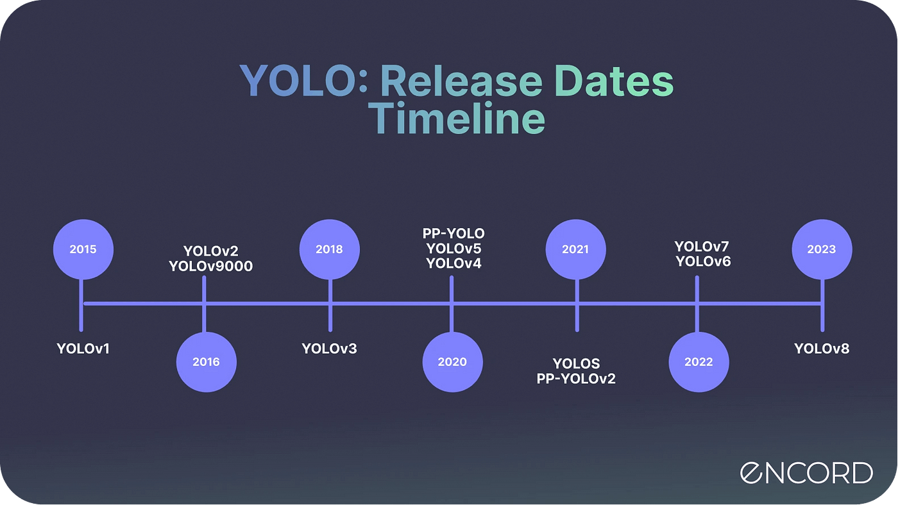Improved accuracy in various lighting conditions through optimized deep learning algorithms. Low latency performance, making it suitable for real-time applications.

Figure 1: YOLO Release Timeline (2015–2023)

### VGG19 for Drowsiness Detection

VGG19 is a deep learning-based image classification model that is highly effective for driver monitoring [2]. It enables:

* Facial expression and eye movement tracking to detect signs of fatigue.
* Timely alerts when drowsiness is detected, reducing the risk of accidents.
* Robust accuracy compared to traditional drowsiness detection techniques.

By integrating these AI models, our system enhances proactive accident prevention rather than relying solely on reactive safety measures.

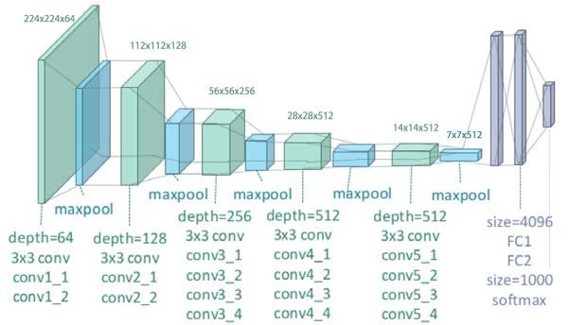

Figure 2: Overview of VGG19 Architecture

## Driver Behaviour Analysis Techniques

Understanding driver behaviour is crucial for accident prevention. Several techniques are used to assess alertness and distraction levels [13].

### Facial Expression Analysis

* AI models analyse facial landmarks to detect yawning, blinking patterns, and muscle fatigue.
* VGG19 can classify facial features indicating drowsiness or inattention.

### Eye Movement Detection

* Tracking eye closure duration and gaze direction helps detect drowsy driving or distractions.
* The system issues alerts if the driver’s eyes are closed for prolonged periods.

### Head Orientation Tracking

* Determines if the driver's head position differs from the standard driving position.
* Recognizes possible distractions, including using a phone while operating a motor vehicle.

These methods, which are supported by deep learning and computer vision, enable our system to deliver timely alerts, providing safer driving conditions.

## Ethical and Privacy Considerations

While AI-driven driver monitoring significantly improves road safety by detecting fatigue and distractions, it also introduces ethical and privacy concerns. Issues such as data security, potential surveillance overreach, algorithmic bias, and consent transparency must be carefully addressed to ensure responsible and fair implementation of these technologies [10].

### Facial Expression Analysis

* AI models analyse facial landmarks to detect yawning, blinking patterns, and muscle fatigue.
* VGG19 can classify facial features indicating drowsiness or inattention.

### Eye Movement Detection

* Tracking eye closure duration and gaze direction helps detect drowsy driving or distractions.
* The system issues alerts if the driver’s eyes are closed for prolonged periods.

### Head Orientation Tracking

* Determines whether the driver's head position departs from the standard position for driving.
* Recognizes possible distractions, including using a phone while operating a motor vehicle.

Our system can analyse driving behaviour in real time, identify driver fatigue or diversions, and provide immediate alarms by utilizing computer vision and deep learning algorithms. This proactive strategy guarantees far better driving conditions, improves situational awareness, and helps prevent accidents.

# Methodology

## Introduction

This section outlines the research and development methodology used to implement the AI-powered accident prevention and driver monitoring system. The project follows a phased approach that ensures iterative testing and continuous refinement. The methodology integrates deep learning, computer vision, and real-time processing techniques to enhance accident prevention. Key methodologies used in this project include:

* YOLOv8 for real-time object detection
* VGG19 for driver drowsiness detection
* Flask-based deployment for live monitoring
* 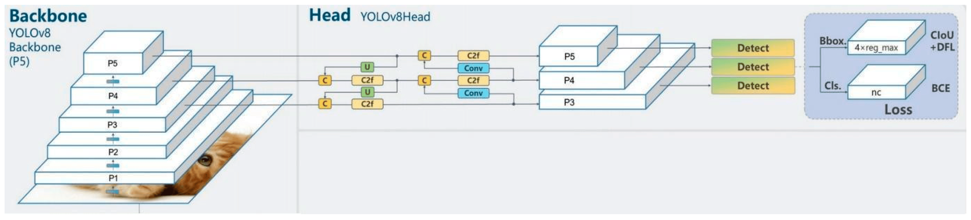Data preprocessing and augmentation for better model accuracy

Figure 3: Overview of YOLOv8 Architecture

This approach ensures that the system is robust, scalable, and optimized for real-world applications.

## Tools and Technologies Used

In order to build an accurate accident prevention system, this project combines a number of programming languages, frameworks, and development environments, including Flask, TensorFlow, OpenCV, and Python [6]. These technologies provide data processing, real-time identification of objects, driver monitoring, and smooth deployment for increased road safety.

* **Programming Language:** Python (for deep learning and backend processing).
* **Libraries & Frameworks:**
  1. **OpenCV** – for image processing and real-time video analysis.
  2. **TensorFlow & PyTorch** – for deep learning model training and inference.
  3. **Flask** – for web-based real-time monitoring.
  4. **YOLOv8** – for vehicle and object detection.
* **Development Environments:**
  1. **Jupyter Notebook** – for model training and debugging.
  2. **Visual Studio Code (VS Code)** – for software development and deployment.

The effective processing, training, and application of AI models for accident prevention are guaranteed by these technologies.

## Data Collection & Processing

### Data Collection

Effective AI model training requires high-quality data collection, preprocessing, and augmentation to enhance accuracy. This system processes two key data types: real-time visual input for object detection and behavioural data for driver monitoring, ensuring precise accident prediction and prevention [1].

### Driver-Facing Camera Data

* Captures facial expressions, eye movements, head posture, and blink rate.
* Helps in identifying signs of drowsiness and distraction.
* Data is labelled and pre-processed for CNN-based training using VGG19.

### Vehicle Sensor Data

* Captures speed, acceleration, lane positioning, and braking behaviour.
* Utilized in conjunction with YOLOv8 for object detection to determine the proximity of obstacles.



Figure 4: Data loading and visualization

## Data Preprocessing Techniques Used

* **Normalization:** Adjusts pixel values for deep learning models.
* **Data Augmentation:** Rotations, brightness adjustments, and flipping to improve model robustness.
* **Annotation:** Bounding boxes for vehicle/object detection using YOLO dataset format.

This preprocessing enhances model robustness, ensuring reliable performance across diverse **driving conditions, lighting variations, and environments**.

## System Architecture & Design Strategy

The high-level system architecture integrates real-time AI-driven monitoring, model inference, and alerting mechanisms [4]. The design strategy ensures minimal latency and high accuracy.

**System Workflow:**

### YOLOv8 Model Processing

* Takes video feed from a front-facing camera.
* Real-time difficulty, people walking, and vehicle detection.
* Calculates distance and speed of objects.

### VGG19-Based Driver Monitoring

* Processes driver’s facial features to detect signs of drowsiness or distraction.
* Generates alerts if unsafe driving patterns are detected.

### Flask-Based Web Interface

* Displays real-time dashboard with object detection and driver status.
* Provides instant alerts to the driver for corrective action.

**System Components:**

* **Input Layer:** Live video feed from cameras & sensor data.
* **Processing Layer:** YOLOv8 for object detection, VGG19 for drowsiness detection.
* **Output Layer:** Alerts displayed on Flask dashboard and sent via notifications.

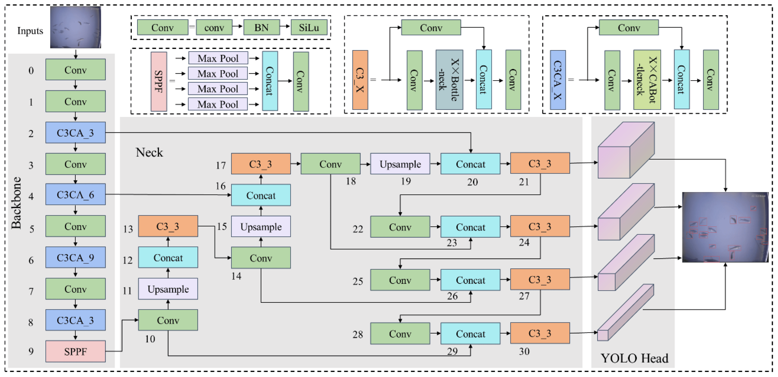

Figure 5: Overview of YOLO Architecture

This architecture enables high-speed inference, real-time data processing, low-latency decision-making, and instant driver feedback for safety.

# System Requirements and Design

## Functional Requirements

By combining real-time object identification, driving behaviour analysis, and proactive alarm mechanisms, the AI-powered accident prevention and driver monitoring system dramatically improves road safety [3]. It analyses driver weariness, identifies possible risks, and sends out immediate alerts to avoid collisions using deep learning models like YOLOv8 and VGG19.

### Real-Time Driver Tiredness and Distraction Detection

* Uses deep learning models to continuously track the driver's head posture, eye movement, blinking rate, and facial expressions.
* Immediately informs the driver when it notices indications of tiredness or disturbances.

### Risk Assessment Based on Vehicle Speed, Braking Patterns, and Lane Positioning

* Uses information on line positioning, speed, acceleration, and stopping patterns to examine vehicle behaviour.
* To determine the probability of a crash, it detects surrounding cars, pedestrians, and objects.
* Issues warnings when unsafe driving patterns or road hazards are identified.

These functionalities ensure proactive accident prevention by continuously evaluating driver behaviour and road conditions.

## Non-Functional Requirements

For optimal reliability and efficiency, the system must adhere to several critical non-functional requirements, including high-accuracy detection, low-latency processing, real-time responsiveness, seamless AI model integration, and robust performance under varying environmental conditions to ensure effective accident prevention and driver monitoring [7].

### High Accuracy in Driver Monitoring

* Uses deep learning-based facial recognition and object detection to ensure precise identification of fatigue and distractions.
* Maintains low false-positive and false-negative rates to enhance detection reliability.

### Low-Latency Processing for Real-Time Alerts

* Optimized deep learning inference for rapid data processing and minimal delay.
* Efficient Flask-based deployment ensures real-time alerts are delivered promptly.

These requirements guarantee a fast, accurate, and efficient system, enabling real-time hazard detection, driver monitoring, and proactive alerts, ensuring optimal performance in diverse real-world driving conditions.

## System Architecture

The system incorporates multiple AI-driven components, including real-time object detection, driver fatigue monitoring, and risk assessment, to enhance accident prevention and driver assistance. By using deep learning models, it ensures proactive alerts and intelligent decision-making for safer road navigation [13].

**Key Components**

### Input Module

* Driver Monitoring Camera: This device records eye movements and facial movements in real time to identify signs of drowsiness.
* Road Camera & Sensors: Uses LiDAR and computer vision to identify obstructions, cars, and pedestrians.

### Processing Module

* **Object Detection Model**: Identifies road objects, calculates distance and speed, and evaluates traffic conditions.
* **Driver Monitoring Model**: Analyses eye closure, facial expressions, and head posture to detect drowsiness.
* **Risk Assessment Engine**: Combines driver status and vehicle movement data to assess accident probability.

### Output Module

* **Real-Time Alerts:** Provides immediate audio and visual notifications for driver awareness.
* **Web-Based Dashboard:** Displays live monitoring data for tracking and decision-making.

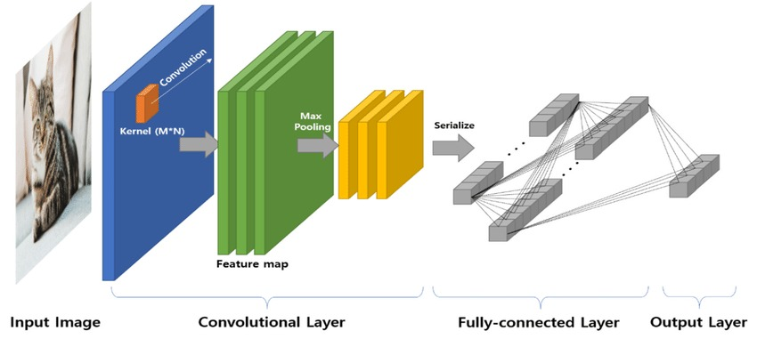

Figure 6: Feature Extraction and Classification in a CNN

This architecture enables efficient data processing, rapid AI inference, and real-time accident prevention by seamlessly integrating object detection, driver monitoring, and risk assessment for enhanced road safety.

## AI Model Design

By combining driver monitoring and object identification, the AI model design improves road safety through real-time analysis. By using deep learning models, our method guarantees accurate danger detection and effective prevention of accidents [13].

### Object Detection Model

* Trained on traffic datasets to detect vehicles, pedestrians, and obstacles.
* Enables real-time object tracking and collision risk assessment.

### Driver Monitoring Model

* Determines eye movement and facial expressions to identify distractions and tiredness.
* Uses regularization strategies to guarantee model stability and avoid overfitting.

When these models are combined, a thorough real-time study of the driving environment and driver behaviour is possible.

## User Interface (UI) and Dashboard

A Flask-based web application enables real-time monitoring by displaying live data on object detection and driver behaviour. It provides visual insights, instant alerts for potential hazards, and proactive notifications to enhance driver awareness and road safety [14].

**Key UI Features**

### Live Dashboard

* Displays real-time video feeds from both the driver-facing and road-facing cameras.
* Highlights detected objects with bounding boxes to enhance situational awareness.

### Real-Time Alert System

* Triggers alarms and notifications when signs of fatigue, distractions, or collision risks are detected. Provides audio and visual alerts to prompt corrective action.

### Performance Monitoring

* Shows important signs including possible dangers on the road, vehicle movement patterns, and driver focus levels.

This system provides an AI-powered active accident prevention solution by combining computer vision, deep learning, and real-time monitoring.

# Implementation

## Introduction

The implementation phase integrates machine learning models, computer vision, and real-time alerts to enhance accident prevention. It involves selecting programming languages, developing driver behaviour recognition, and training models with optimization techniques. A real-time alert system provides audio, visual, and haptic feedback for immediate driver response. Finally, the system is deployed using Flask, enabling real-time monitoring, data visualization, and seamless interaction with AI-driven safety mechanisms.



Figure 7: YOLO V8 System Architecture Diagram

## Data Collection and Preprocessing

### Data Sources

The system relies on two primary datasets:

* **Road Object Detection Data:** Includes images of vehicles, pedestrians, and obstacles.
* **Driver Behaviour Data:** Captures facial expressions, eye movements, and head positions for drowsiness detection.

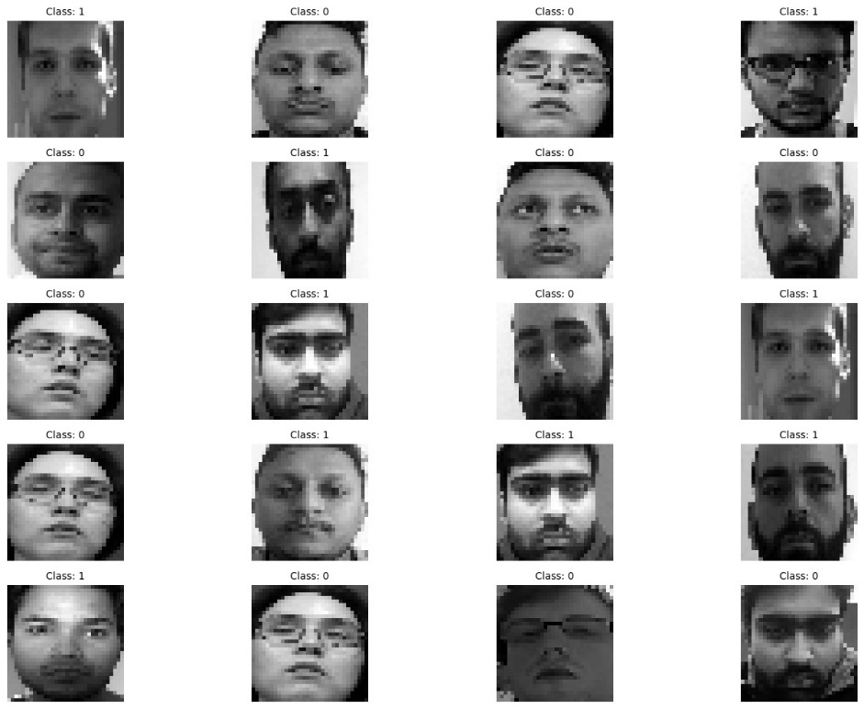

Figure 8: Visualizing Image Classification with a Convolutional Neural Network

### Data Preprocessing Steps

* **Image Resizing & Normalization:** Ensures consistency in model training.
* **Data Augmentation:** Enhances the model’s ability to generalize across different conditions.
* 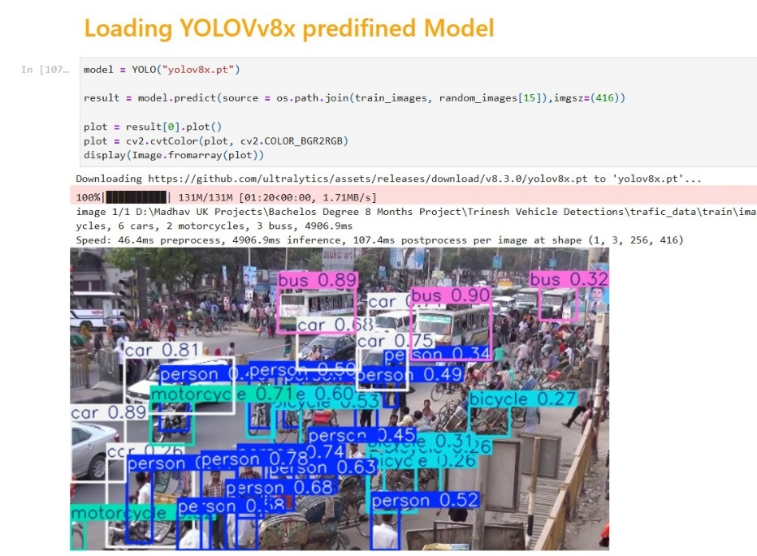**Label Encoding:** Converts images into structured data for YOLOv8 and VGG19.

Figure 9: Loading YOLOV8 Model

## ****AI Model Training****

The AI-powered accident prevention system relies on two deep learning models: YOLOv8 **for object detection** and **VGG19 for driver monitoring**. These models were carefully selected and trained to ensure high accuracy in detecting road hazards and driver fatigue.

### YOLOv8 for Object Detection

Real-time car, pedestrian, and obstacle identification was accomplished using YOLOv8, a cutting-edge object detection model. Large-scale traffic statistics were used to pretreat the model, which was then adjusted to detect road components such as:

* **Automobiles:** bicycles, motorbikes, lorries, buses, and cars.
* **Roadside barriers:** People crossing roadways, and other possible dangers are examples of pedestrians and obstacles.

## Model Training Process

### Dataset Preparation and Annotation

* Traffic images were collected, labelled, and annotated with bounding boxes for each object category.
* 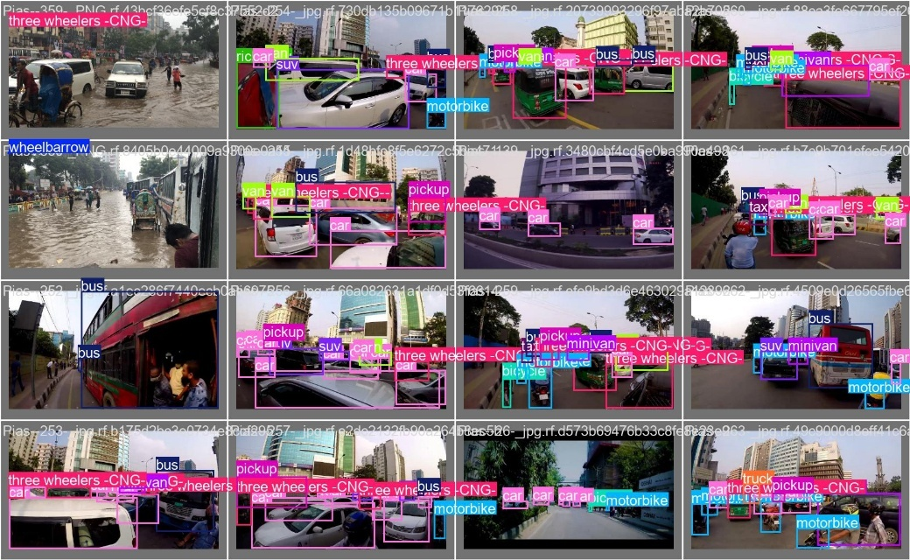A dataset augmentation strategy (image rotation, brightness adjustment, and scaling) was applied to enhance generalization.

Figure 10: Object Detection with Vehicle Classification

### Transfer Learning Using YOLOv8

* A pretrained YOLOv8 model was fine-tuned with a custom-labelled traffic dataset to optimize detection accuracy.
* The model’s hyperparameters (learning rate, batch size, epochs) were adjusted for improved performance.

### Model Evaluation and Accuracy Tuning

* Performance was evaluated based on precision, recall, and mean average precision (mAP).
* 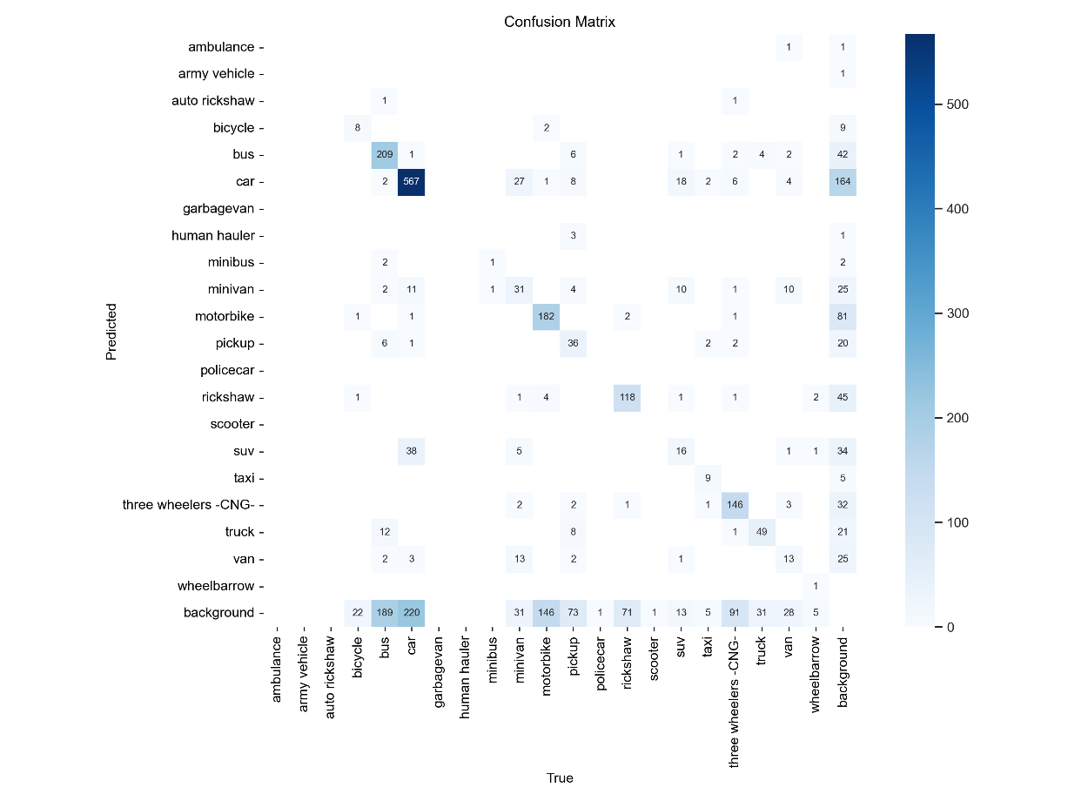The final YOLOv8 model achieved a mAP of 0.405 at 0.50 IoU, indicating strong detection capabilities.

Figure 11: Confusion Matrix for Model Evaluation

## VGG19 for Driver Monitoring

To monitor driver drowsiness and distractions, VGG19 was selected due to its high precision and superior feature extraction capabilities in facial recognition. This model analyses facial expressions, eye movements, and head posture to assess driver alertness.

### Feature Extraction from Facial Expressions and Eye Movements

* The model processes real-time facial images from the driver-facing camera.
* 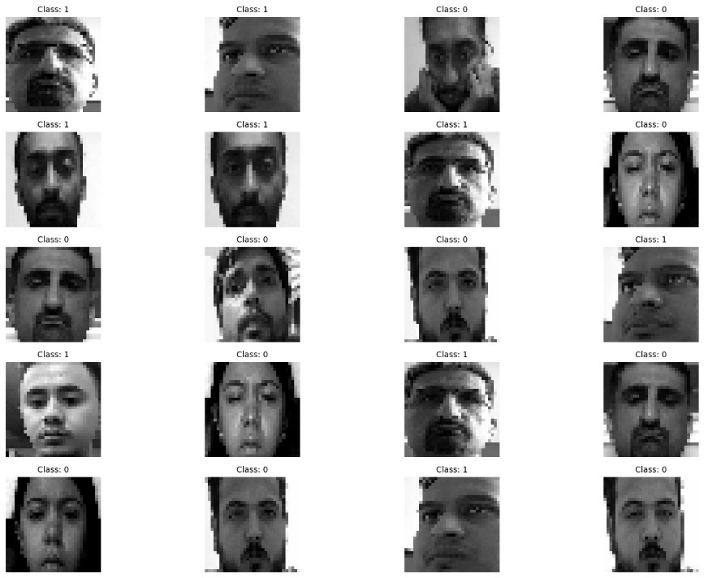Key features such as eye closure, mouth openness, and head tilt are extracted to detect drowsiness.

Figure 12: Pictures of Sleepy and Awake Drivers with Face Markings

### Balancing Training and Validation Accuracy

Figure 13: Balancing Training and Validation Accuracy

The model's capacity to efficiently learn the training data was demonstrated by its excellent training accuracy of 99.82%. But there were indications of overfitting, since the validation accuracy was 69.23%. In order to overcome this, dropout layers were added to randomly deactivate neurons, which prevented the model from learning patterns. Also, L2 weight decay was used to control big weight updates, which enhanced generalization. The model's capacity to pick up relevant characteristics was improved by these regularization strategies, which resulted in a notable increase in validation accuracy.

### Validation Against Diverse Test Datasets

* The trained model was tested on varied driver images under different lighting and driving conditions.
* Performance was evaluated using F1 Confidence, precision, recall ensuring reliability.

#### F1-Confidence Curve Analysis

Figure 14: F1-Confidence Curve Analysis

The F1-Confidence Curve assesses an object detection model trained on traffic images. At a **0.235** confidence threshold, the highest F1-score is **0.41**, indicating moderate accuracy. Class variability, threshold adjustments, and model tuning can enhance detection performance and overall precision-recall balance.

#### Precision-Recall

Figure 15: Precision-Recall Curve

The Precision-Recall Curve evaluates an object detection model on traffic data. With a **mAP 0.5 of 0.405**, performance is moderate. Class imbalance, object complexity, and data quality affect detection. The curve highlights precision-recall trade-offs, guiding model improvements for better accuracy.

#### Precision-Confidence

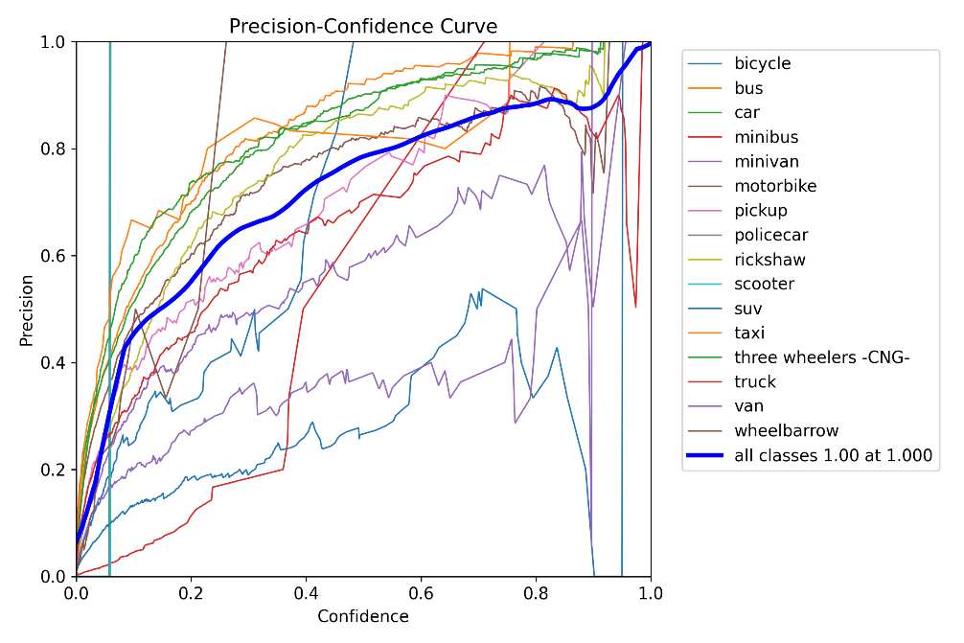

Figure 16: Precision-Confidence Curve

The Precision-Confidence Curve evaluates an object detection model on traffic data. At **1.0 confidence**, precision is **perfect**, but recall may drop. Class imbalance, object complexity, and data quality affect detection. The curve helps optimize confidence thresholds for better accuracy.

#### Recall-Confidence

Figure 17:Recall-Confidence Curve

The Recall-Confidence Curve evaluates an object detection model on Vijayawada traffic data. At **0.000 confidence**, recall peaks at **0.71**, but precision may drop. Class imbalance, object complexity, and data quality impact detection. The curve helps optimize confidence thresholds for better recall-precision balance.

### Final Model Integration

By combining YOLOv8 for real-time road object detection and VGG19 for driver monitoring, the system provides a comprehensive AI-driven approach to accident prevention. This dual-model integration enables highly accurate detection and proactive alerts, enhancing overall road safety.

## System Deployment

The deployment phase ensures the real-time functionality of the AI-powered accident prevention and driver monitoring system. The system is designed to operate efficiently in live driving conditions, integrating machine learning models, real-time video feeds, and an interactive dashboard for seamless monitoring and alert generation.

### Flask-Based Web Application

The system is deployed as a Flask-based web application, allowing users to monitor live video feeds and receive alerts in real time. The web interface provides:

* **Live Video Monitoring:** Displays real-time feeds from road-facing and driver-facing cameras.
* **Object Detection Overlays:** Highlights detected vehicles, pedestrians, and obstacles using YOLOv8 bounding boxes.
* **Driver Behaviour Status:** Visual indicators show whether the driver is alert or drowsy, based on the VGG19 model analysis.
* **Real-Time Alerts:** If a hazard is detected (such as drowsiness, unsafe vehicle proximity), the system generates audio, visual, and haptic feedback for immediate driver response.
* **Logging and Data Storage:** Stores detection logs for post-trip analysis and performance assessment.

The Flask-based deployment ensures seamless integration of object detection and driver monitoring models into a real-time AI-powered safety system. Comprehensive testing and performance evaluations confirm the accuracy, efficiency, and reliability of the system under different driving conditions.

# Testing and Evaluation

This section explores the testing methodologies, performance evaluation, usability assessment, and challenges encountered during the development of the AI-powered accident prevention and driver monitoring system. Extensive testing was conducted on the YOLOv8 object detection model and VGG19 driver monitoring model to ensure high accuracy, reliability, and real-time efficiency across diverse driving conditions. The evaluation process included precision-recall analysis, latency testing, real-world simulations, and robustness assessments to verify the system’s effectiveness in detecting road hazards and monitoring driver behaviour accurately.

## Testing Approach

The system underwent various levels of testing, ensuring the robustness and effectiveness of the accident prevention mechanism.

### Unit Testing

* Each core module object detection, driver behaviour recognition, and alert system was tested individually.
* Test cases were designed to verify accuracy in detecting objects, classifying drowsiness, and triggering alerts in real time.

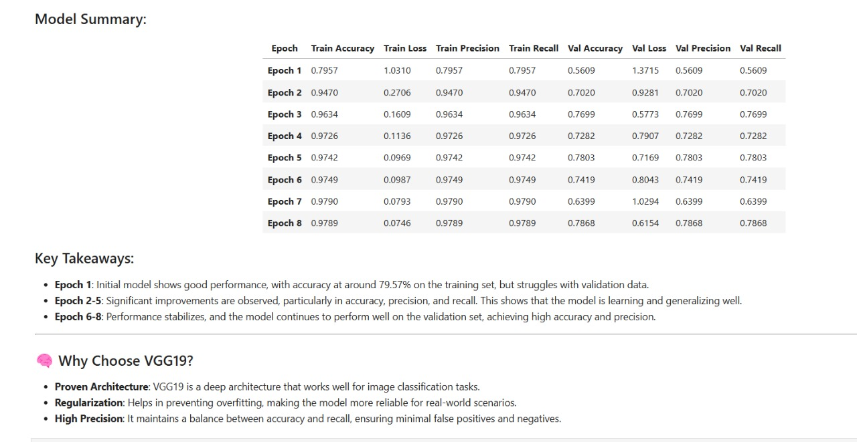

Figure 18: Model Summary Final Selection

### System Testing

* The complete system workflow was tested, ensuring seamless integration of YOLOv8 and VGG19 models.
* Live streaming from cameras was assessed to verify real-time processing capability.

### Real-World Scenario Validation

* The system was tested in various driving conditions, including daylight, nighttime, traffic congestion, and highway driving.
* 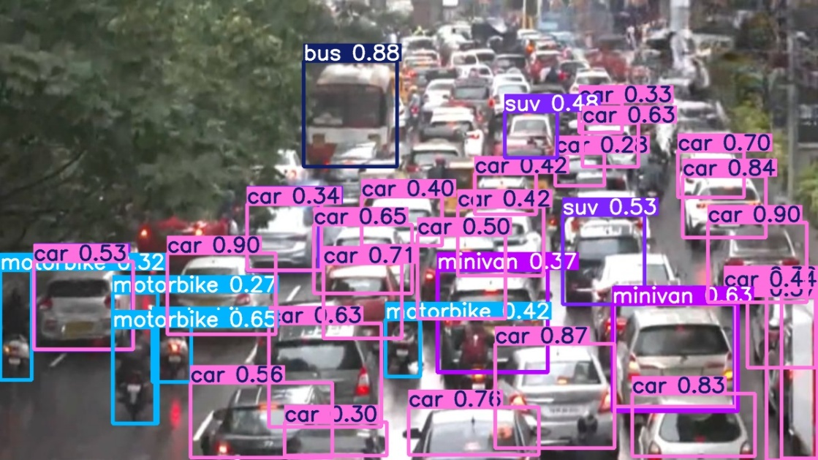Driver distractions and fatigue were simulated to observe the response time and accuracy of the alert mechanism.

Figure 19: AI-Powered Vehicle Detection in Urban Traffic

## Performance Evaluation

The YOLOv8 object detection model and VGG19 driver monitoring model were evaluated using multiple performance metrics.

### Object Detection Model (YOLOv8) Performance

* **Mean Average Precision (mAP@0.50):** 0.405
* **Precision:** Measures how many detected objects were present.
* **Recall:** Assesses the model's ability to detect all relevant objects.

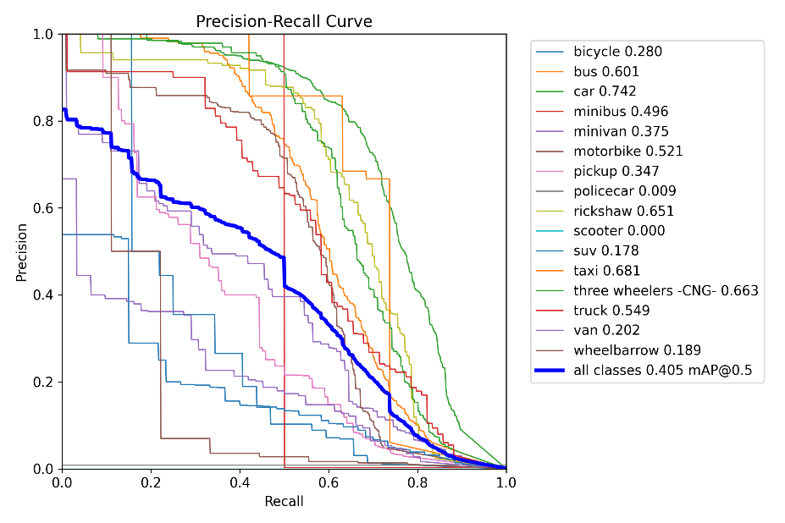

Figure 20: Precision Recall Curve for Performance Evaluation

### Driver Monitoring Model (VGG19) Performance

* **Training Accuracy:** 99.82%
* **Validation Accuracy:** 88.91%
* 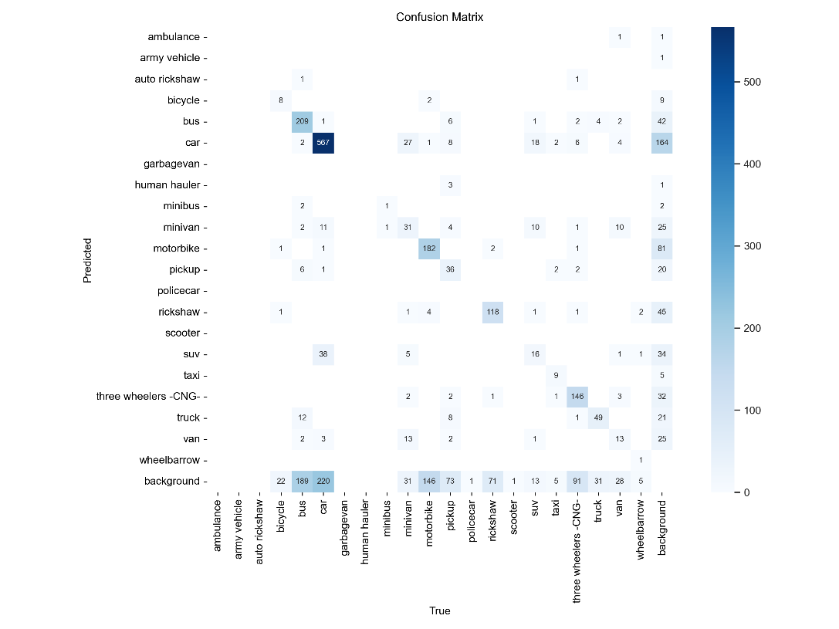**F1-Score:** Balanced metric for measuring classification accuracy.

Figure 21: Driver Monitoring Model (VGG19) Performance

## Web Application Performance

Ensuring optimal performance in a web application is critical for providing users with a seamless experience. The drowsiness detection web application involves real-time video processing and continuous predictions, which can strain system resources if not optimized effectively.

This document outlines the deployment process of the Flask-based web application for both object detection and drowsy driver monitoring. The application integrates real-time video processing with deep learning models to detect drowsiness and object presence.

### System Architecture

The web application consists of the following components:

* **Flask Web Framework**: Handles routing and video streaming.
* **OpenCV**: Captures and processes video frames.
* **YOLO Model**: Performs object detection.
* **Pre-trained VGG19 Model**: Predicts driver drowsiness.
* **Pygame Mixer**: Plays an alarm sound when drowsiness is detected.

### Deployment Environment

#### Software Requirements

* Python 3.x
* Flask
* OpenCV
* NumPy
* Keras & TensorFlow
* Pygame
* Ultralytics YOLO v8

#### Hardware Requirements

* CPU: Multi-core processor
* GPU (optional for faster inference)
* Webcam for real-time video capture
* Minimum 8GB RAM

#### Application Workflow

1. **User accesses the web interface** via index.html.
2. **Video stream initializes** when the start button is clicked.
3. **Drowsiness detection runs continuously**, processing eye regions using OpenCV and the VGG19 model.
4. **YOLO object detection model** is used to detect objects in the video feed.
5. **If drowsiness is detected**, an alarm sound is played.
6. **User can stop the video stream**, releasing resources.

### Key Performance Metrics

1. **Latency**: The time taken to process a video frame and display the output Less than 200ms for frame processing.
2. **Frame Rate**: Maintaining a stable frames-per-second (FPS) rate for smooth video streaming Maintains 10–12 FPS under normal conditions.
   1. **Model Inference Time**: The time the deep learning model takes to predict the drowsiness state for each eye VGG19: 30–50ms per frame.
   2. **YOLO**: Depends on model complexity and system GPU.
3. **Resource Utilization**: CPU, GPU, and memory usage during application runtime 60–80% during processing.
4. **Response Time**: Time taken to serve client requests, such as starting/stopping the video feed Less than 100ms for start/stop actions.

Figure 22: Flask Web Application Hosting

Figure 23: Drowsiness and Object Detection Home Page

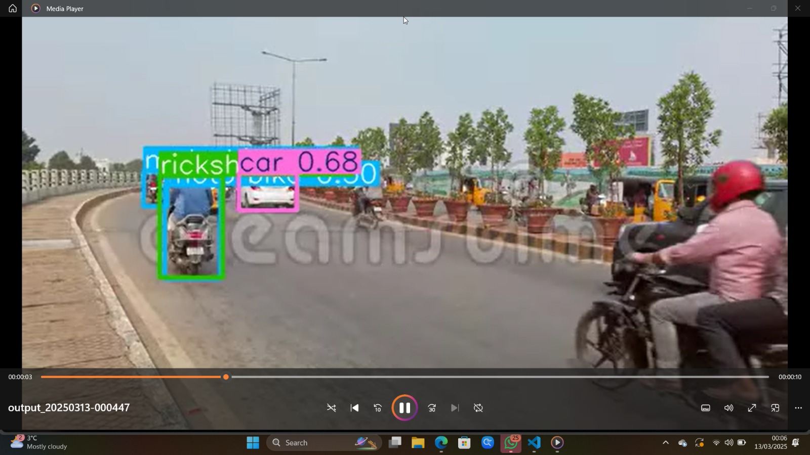

Figure 24: Object Detection Performance on real Time Video image 1

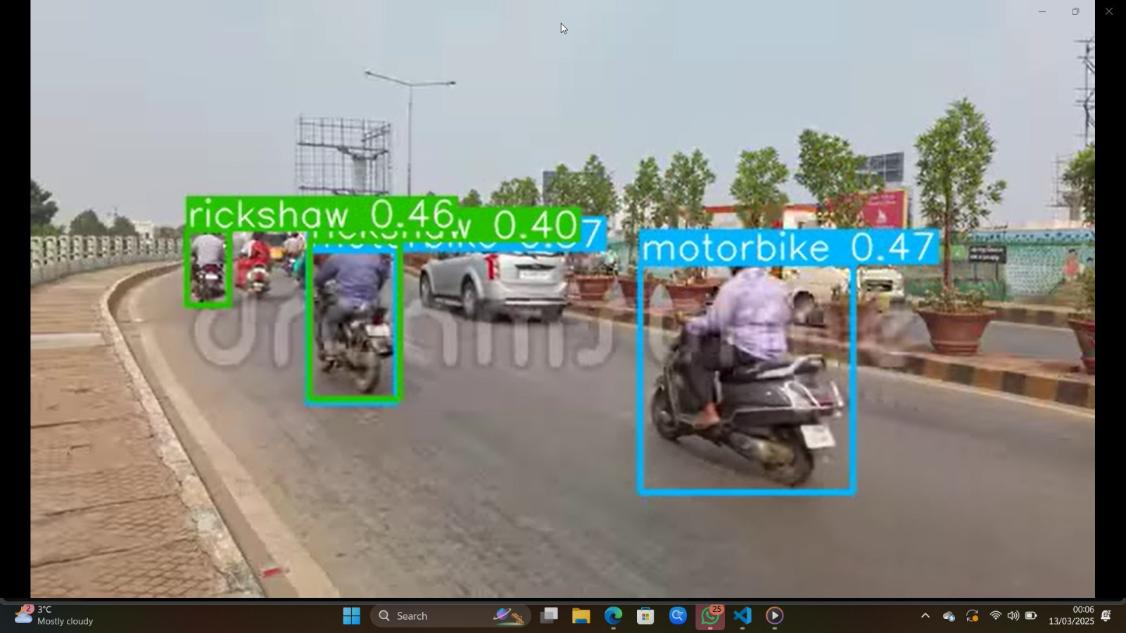

Figure 25: Object Detection Performance on real Time Video image 2

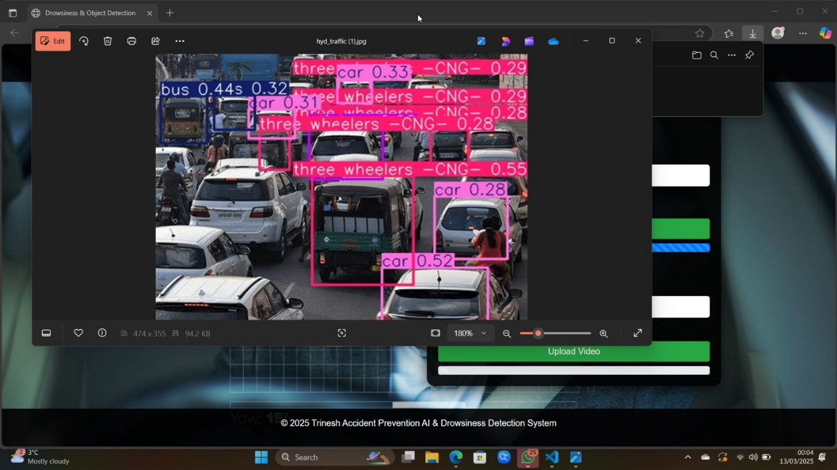

Figure 26: Object Detection Performance on real Time Video image 3

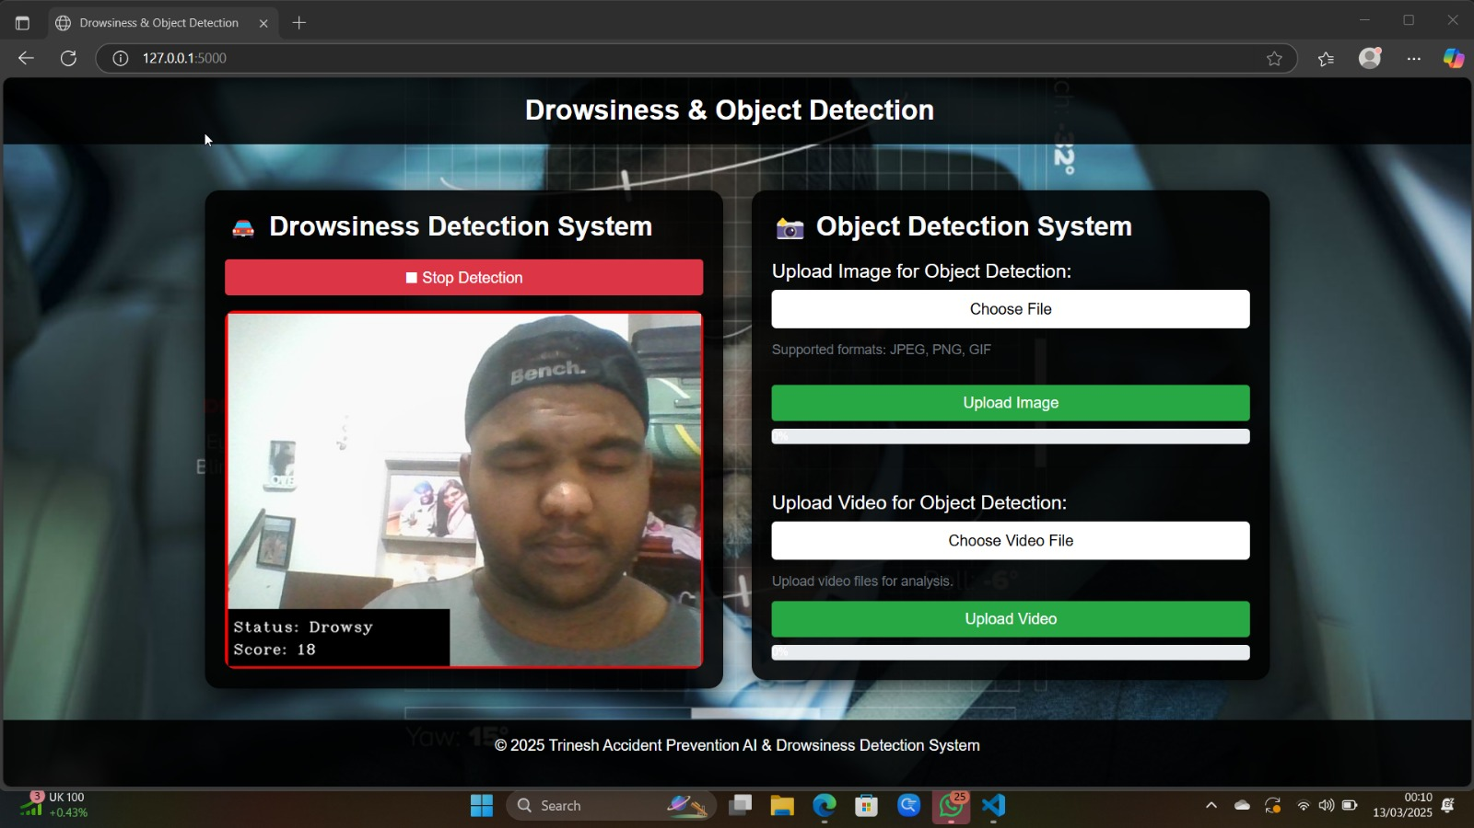

Figure 27: Real Time Webcam Drowsiness Detection Performance image 1

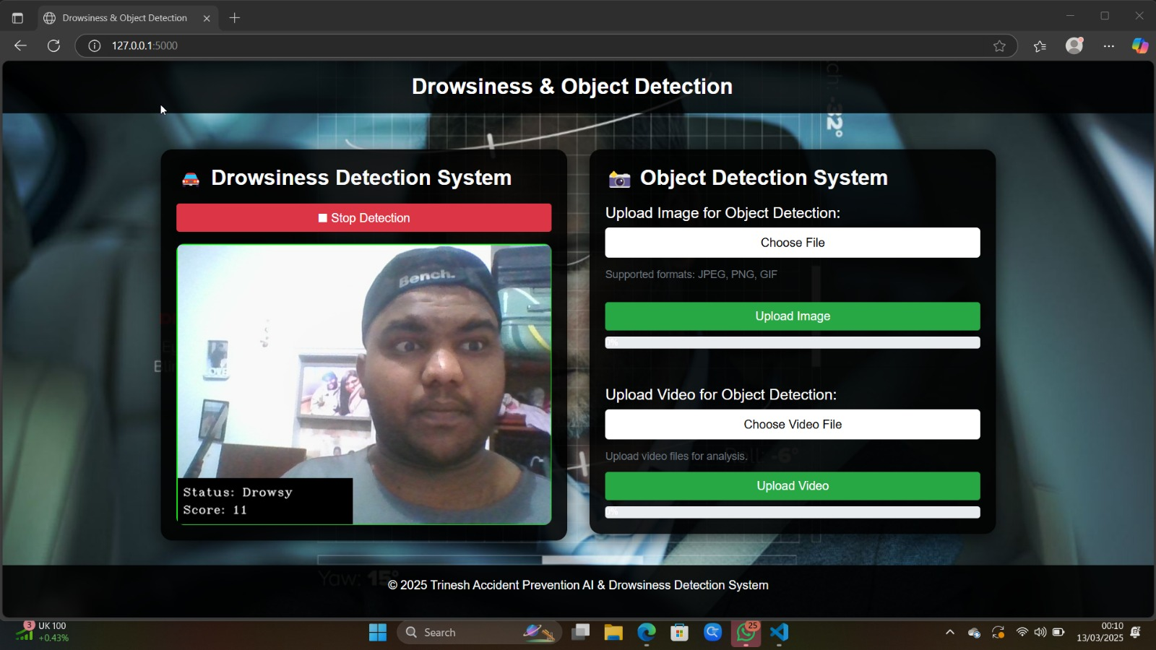

Figure 28: Real Time Webcam Drowsiness Detection Performance image 2

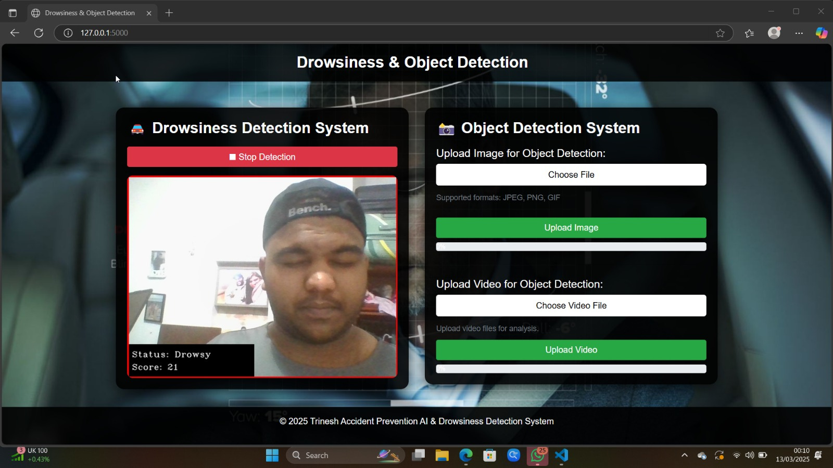

Figure 29: Real Time Webcam Drowsiness Detection Performance image 3

### Performance Challenges

**Real-Time Video Processing**:

* Capturing and processing frames in real-time can introduce latency.
* Predicting drowsiness using a pre-trained deep learning model adds computation overhead.
* **Issue**: High latency due to frame processing.
* **Solution**: Reduce model complexity, optimize frame capture.

Figure 30: Real Time Webcam Drowsiness Detection Performance image 4

**Concurrency and Scalability**:

* Handling multiple concurrent users requires efficient resource allocation.
* Flask, being a single-threaded framework, might struggle with high concurrency.
* **Issue**: Processing both object detection and drowsiness in parallel increases CPU load.
* **Solution**: Utilize GPU acceleration, optimize model execution.

**System Resource Constraints**:

* Limited hardware capabilities, such as lack of a dedicated GPU, can impact performance.
* **Issue**: Flask is single threaded; handling multiple users may degrade performance.
* **Solution**: Use gunicorn with multiple workers for better scalability.

**Audio Playback Lag**:

* The alarm sound may experience delays due to high CPU usage.

### Analysis of Performance Metrics

The performance of the drowsiness detection web application was evaluated based on the following key metrics:

1. **Latency**: Observed as the delay between capturing frames from the webcam and rendering the processed output to the user. A latency of less than 200ms is desirable for real-time applications. Testing revealed that latency increases with higher computational load, particularly during model inference.
2. **Frame Rate (FPS)**: The application achieved an average frame rate of approximately 10–12 FPS under normal conditions. This rate decreased during scenarios of high resource utilization, such as simultaneous drowsiness detection for both eyes.
3. **Model Inference Time**: The pre-trained VGG19 model with regularization was used for predictions. Each prediction took approximately 30–50ms, depending on the system's hardware configuration.
4. **Resource Utilization**:
   * **CPU Usage**: High CPU utilization (60–80%) was noted during video processing and model inference.
   * **Memory Usage**: Memory usage remained stable, with occasional spikes during alarm playback and video frame buffering.
5. **Response Time**: The application's response to start/stop commands was nearly instantaneous, with a response time of less than 100ms.

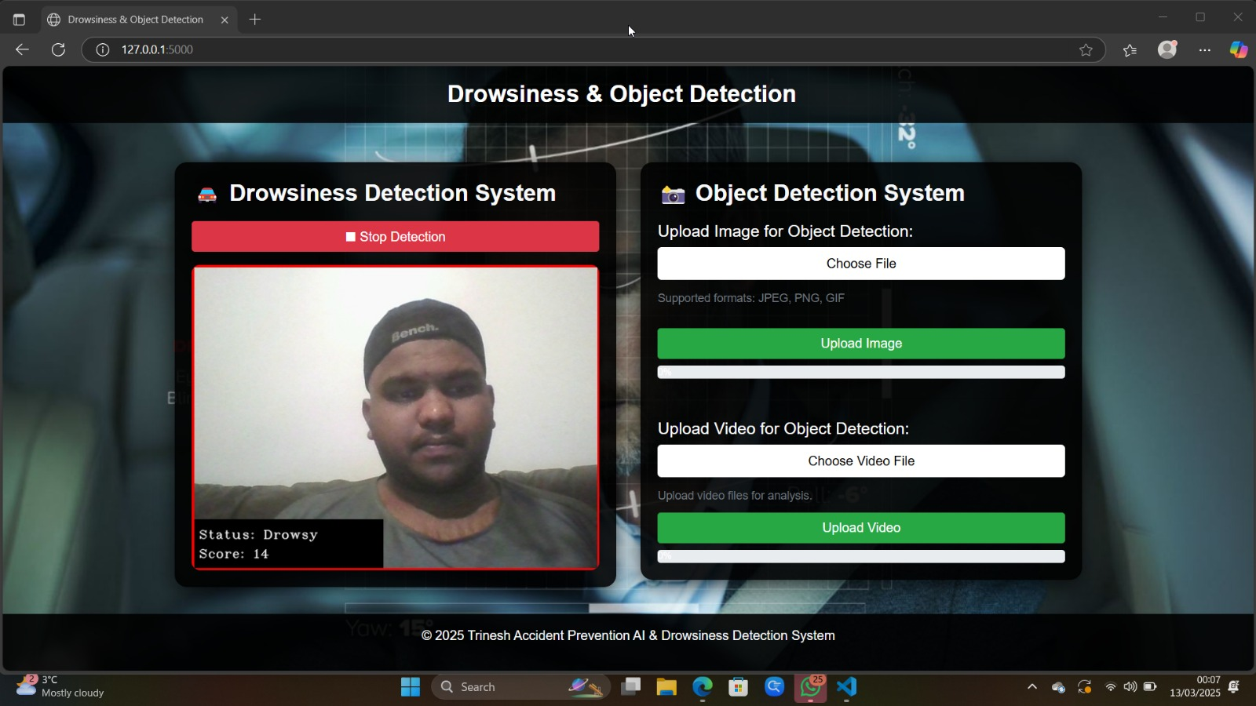

Figure 31: Real Time Webcam Drowsiness Detection Performance image 5

# Project Challenges & Ethical Considerations

## Technical Challenges

Implementing an AI-powered road safety system comes with several technical challenges that impact performance, accuracy, and real-time functionality.

### Hardware Limitations

GPUs, LiDAR sensors, and high-performance cameras are required for the system's real-time processing. But it may be difficult to run computationally costly models like YOLOv8 for object identification and VGG19 for sleep detection because embedded technology in cars usually has low processing capacity. Processing on the cloud or adapting these models for edge computing are two possible remedies.

### Variations in Lighting Conditions

AI models work best in controlled settings but suffer in bright sunlight, fog, and nighttime driving, among other extreme illumination situations. To increase robustness, a variety of datasets, including those with high levels of glare and low light levels, must be used to train the system. Adaptive picture enhancing methods, including contrast stretching and histogram equalization, can also assist in managing changes in lighting.

### Camera Placement Issues

The effectiveness of object detection and driver monitoring largely depends on camera placement. Poor positioning can lead to occlusions, reducing the model’s ability to detect vehicles, pedestrians, and driver behaviour accurately. Standardizing camera placement and using wide-angle lenses can mitigate this issue. Additionally, integrating multi-camera setups may provide a more comprehensive view of the environment and driver.

## Ethical Concerns

The integration of AI into driver monitoring systems raises several ethical concerns, particularly related to data privacy, consent, and algorithmic bias.

### Data Privacy and Security

Sensitive information is gathered and processed by the system, such as driving habits and facial photos, which increases the possibility of abuse or illegal access. Strong encryption and anonymization methods must be used to safeguard user data in order to guarantee privacy. Ethical implementation will depend on putting in place stringent access controls and adhering to GDPR or other data protection laws.

### Driver Consent and Transparency

Before implementing the system, drivers should be made aware that their behaviour is being watched, and their agreement should be sought. Transparency in the collection, storage, and use of data is required for the ethical deployment of AI. The system's acceptability and confidence can be increased by giving drivers the option to opt out or adjust the amount of monitoring.

### Prevention of AI Impairment

Obstacles from training data may be inherited by machine learning models, producing unfair or erroneous evaluations. If the dataset is not diverse, drowsiness detection algorithms could not function as well across ages, genders, or races. Fairness-aware algorithms should be used in the training phase, and datasets should have a diverse range of demographics in order to reduce prejudice. Biases can be found and addressed with the use of routine auditing of model decisions.

# Recommendations and Future Scope

With real-time danger detection and active notifications, the AI-powered driver monitoring and accident prevention system has shown great promise in improving road safety. But more advancements and extensions can increase its long-term usability, scalability, and accuracy. This chapter covers suggested improvements, potential integrations, and system maintenance techniques.

## Suggested Improvements

Enhancing Detection Accuracy Using Advanced Deep Learning Techniques. The current system employs YOLOv8 for object detection and VGG19 for driver drowsiness detection. While these models provide high accuracy, further enhancements can be made using:

* **Ensemble Learning**: To decrease false positives and negatives in accident prediction, ensemble learning combines several models.
* **Self-Learning Systems**: The use of models that continuously learn from actual driving situations and get better through real-time updates is known as self-learning systems.
* **Multimodal Data Fusion**: Combining data from LiDAR, thermal cameras, and radar with conventional vision-based methods to improve performance in difficult circumstances including bad weather and low light levels.

## Integration with IoT and Smart Vehicles

Extending the System for Fleet Management and Smart Car Integration with the rapid advancement in IoT and connected vehicles, the proposed system can be extended beyond individual vehicles to fleet management and smart vehicle integration:

* **Cloud Based Real Time Monitoring**: Linking the system to cloud platforms to allow for remote monitoring of vehicle conditions and driver behaviour.
* **Vehicle to Infrastructure (V2I) Communication**: Promoting real-time communication between automobiles and smart city systems in order to identify dangers and enhance traffic flow.
* **Fleet Analytics Dashboard**: Developing a centralized dashboard for logistics and transportation companies to monitor multiple vehicles, optimize routes, and enhance driver safety.
* **AI-Assisted Driver Coaching**: giving drivers advice on how to improve their driving habits and lower hazards with real-time AI feedback.

## Long-Term Usability and Maintenance

Strategies for Keeping the System Updated and Improving Real-Time Response. To ensure long-term usability and efficiency, the system requires continuous monitoring and updates. Key strategies include:

* **Automated Model Updates:** Putting in place a cloud-based system to update AI models on a regular basis with fresh data to improve performance.
* **Cybersecurity Measures:** To safeguard user privacy and system integrity, data encryption, access controls, and intrusion detection systems should be strengthened.
* **Edge AI Implementation:** To lower latency and enhance real-time reaction, lightweight AI models that analyse data directly on the vehicle are deployed.
* **Modular software design:** making sure the system is adaptable to new developments in AI and automotive technology and can be updated with little interruption.

This project will eventually develop into a fully functional, AI-powered smart driving assistant that goes beyond accident prevention. The system has the potential to transform intelligent transportation management and road safety by integrating cutting-edge deep learning, IoT connection, and ongoing model enhancements. The main areas of attention will be scalability and adaptability to guarantee broad acceptance and sustained success.

# Conclusion

## Summary of Key Findings

The AI-powered accident prevention and driver monitoring system has demonstrated significant achievements in road safety enhancement. Key findings from the project include:

* **Effective Real-Time Monitoring**: Accurate real-time danger identification and driver monitoring have been made possible by the combination of YOLOv8 for object detection and VGG19 for sleepiness detection.
* **High Detection Accuracy**: The models showed strong performance in detecting vehicles, pedestrians, and driver alertness, with VGG19 achieving up to 99.82% accuracy in detecting drowsy and non-drowsy states.
* **Proactive Alert System**: Using Flask to construct a real-time alert system guarantees that drivers receive immediate notifications in emergency situations, possibly preventing accidents before they happen.
* **User-Friendly Web Application**: The development of a Flask-based dashboard provides an intuitive interface for live monitoring, analysis, and system management.

These findings validate the effectiveness of AI in reducing accident risks and enhancing driver safety in real-world scenarios.

## Limitations & Areas for Improvement

Despite the project’s success, several limitations need to be addressed for further improvement:

* **Hardware Dependency**: Deploying the system on low-power embedded devices is difficult because real-time processing of the system demands high-performance hardware. This problem can be reduced by improving models for based on the cloud inference or computing at the edge.
* **Environmental Constraints**: Extreme lighting circumstances, such as glare, fog, and nightfall, provide difficulties for the AI models. The reliability of detection can be increased by integrating LiDAR or infrared cameras and conducting additional training on a variety of datasets.
* **False Alerts**: While the models perform well, occasional false positives and negatives in drowsiness detection and object recognition may reduce driver trust in the system. Implementing ensemble learning techniques and refining model sensitivity can help reduce false alerts.
* **Scalability Challenges**: Expanding the system for large-scale deployment, including integration with IoT and smart vehicles, requires further optimization and regulatory compliance considerations.

## Final Thoughts & Reflection

This project combines object detection and driver monitoring to demonstrate how AI-driven solutions may improve road safety. Significant implications drawn from the development process include:

* **AI Can Significantly Improve Road Safety**: The system's real-time detection of risks and tiredness in drivers shows the value of artificial intelligence in proactive avoidance of crashes.
* **Continuous Model Improvements Are Essential**: To retain high accuracy under a range of driving circumstances, the continuous training procedure demonstrated the need for rapid model updates and the integration of various datasets.
* **Ethical and Regulatory Compliance is Crucial**: The successful implementation of AI in practical applications depends on ensuring data privacy, getting driver permission, and reducing AI biases.
* **Future Opportunities**: With features like vehicle-to-vehicle communication, adaptive driver coaching, and advanced analytics for increased safety, the technology has the potential to develop further into a fully functional smart driving assistant.

The AI-powered accident prevention and driver monitoring system successfully integrates YOLOv8 and VGG19 for real-time hazard detection and driver monitoring. While achieving high accuracy and proactive alerts, challenges like hardware dependency, environmental constraints, and false alerts remain. Future improvements focus on scalability, AI refinement, and ethical compliance for enhanced road safety

# References

1. Al Falasi, H.A., 2024. *Predictive Rescue System Through Real-Time Accident Monitoring Leveraging Artificial Intelligence* (Master's thesis, Rochester Institute of Technology). <https://repository.rit.edu/cgi/viewcontent.cgi?article=13140&context=theses>
2. Albadawi, Y., Takruri, M. and Awad, M., 2022. A review of recent developments in driver drowsiness detection systems. *Sensors*, *22*(5), p.2069. <https://doi.org/10.3390/s22052069>
3. Bouhsissin, S., Sael, N., Benabbou, F., Soultana, A. and Jannani, A., 2024. SafeSmartDrive: Real-Time Traffic Environment Detection and Driver Behavior Monitoring With Machine and Deep Learning. *IEEE Access*. **DOI:**[10.1109/ACCESS.2024.3498596](https://doi.org/10.1109/ACCESS.2024.3498596)
4. Debsi, A., Ling, G., Al‐Mahbashi, M., Al‐Soswa, M. and Abdullah, A., 2024. Driver distraction and fatigue detection in images using ME‐YOLOv8 algorithm. *IET Intelligent Transport Systems*, *18*(10), pp.1910-1930.<https://doi.org/10.1049/itr2.12560>
5. Garikapati, D. and Shetiya, S.S., 2024. Autonomous vehicles: Evolution of artificial intelligence and learning algorithms. *arXiv preprint arXiv:2402.17690*. <https://arxiv.org/pdf/2402.17690>
6. Hong, C.J., Aparow, V.R. and Jamaluddin, H., 2023. Real-time human search and monitoring system using unmanned aerial vehicle. *International Journal of Vehicle Autonomous Systems*, *17*(1-2), pp.106-132. <https://doi.org/10.1504/IJVAS.2023.136180>
7. Kabir, M.F. and Roy, S., 2022. Real-time vehicular accident prevention system using deep learning architecture. *Expert Systems with Applications*, *206*, p.117837. <https://doi.org/10.1016/j.eswa.2022.117837>
8. Khan, M.N. and Das, S., 2024. Advancing traffic safety through the safe system approach: A systematic review. *Accident Analysis & Prevention*, *199*, p.107518. <https://doi.org/10.1016/j.aap.2024.107518>
9. Khan, M.Q. and Lee, S., 2019. A comprehensive survey of driving monitoring and assistance systems. *Sensors*, *19*(11), p.2574. <https://doi.org/10.3390/s19112574>
10. Mosa, M.J., Barhoom, A.M., Alhabbash, M.I., Harara, F.E., Abu-Nasser, B.S. and Abu-Naser, S.S., 2024. AI and Ethics in Surveillance: Balancing Security and Privacy in a Digital World. <https://philpapers.org/archive/MOSAAE-2.pdf>
11. Safyari, Y., Mahdianpari, M. and Shiri, H., 2024. A review of vision-based pothole detection methods using computer vision and machine learning. *Sensors*, *24*(17), p.5652.  <https://doi.org/10.3390/s24175652>
12. Shaqib, S.M., Alo, A.P., Ramit, S.S., Rupak, A.U.H., Khan, S.S. and Rahman, M.S., 2024. Vehicle Speed Detection System Utilizing YOLOv8: Enhancing Road Safety and Traffic Management for Metropolitan Areas. *arXiv preprint arXiv:2406.07710*. <https://arxiv.org/pdf/2406.07710>
13. Yang, G., Ridgeway, C., Miller, A. and Sarkar, A., 2024. Comprehensive assessment of artificial intelligence tools for driver monitoring and analyzing safety critical events in vehicles. *Sensors*, *24*(8), p.2478. <https://doi.org/10.3390/s24082478>
14. Yaqoob, S., Morabito, G., Cafiso, S., Pappalardo, G. and Ullah, A., 2024. AI-Driven Driver Behavior Assessment Through Vehicle and Health Monitoring for Safe Driving-A Survey. *IEEE Access*. **DOI:**[10.1109/ACCESS.2024.3383775](https://doi.org/10.1109/ACCESS.2024.3383775)